EXPERIMENT 2 – STUDY OF NETWORK CABLES

AIM
To study different types of network cables and to make a straight-through cable and crossover cable using an RJ45 connector and crimping tool.

REQUIREMENTS
- Ethernet cable (CAT5/CAT5e)
- RJ45 connectors
- Crimping tool
- Cable tester (if available)

TYPES OF NETWORK CABLES
- UTP – Unshielded Twisted Pair
- STP – Shielded Twisted Pair
- Coaxial Cable
- Fibre Optic Cable

PROCEDURE
- Take an Ethernet cable and cut it to the required length.
- Strip approximately 1.5 cm of the outer cable covering.
- Untwist and separate the four pairs of wires.
- Arrange the wires according to the required wiring standard.
- For a straight-through cable, use the same arrangement at both ends.
- For a cross-over cable, use arrangement A at one end and arrangement B at the other end.
- Cut the wires evenly and insert them into the RJ45 connector.
- Ensure that all wires reach the end of the connector in the correct order.
- Insert the RJ45 connector into the crimping tool and press firmly.
- Repeat the process for the other end.
- Test the completed cable by connecting it to the appropriate devices.

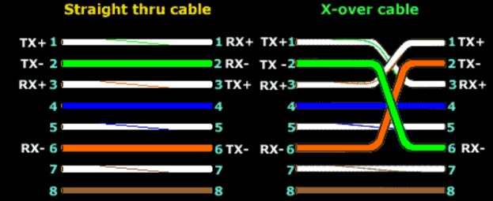

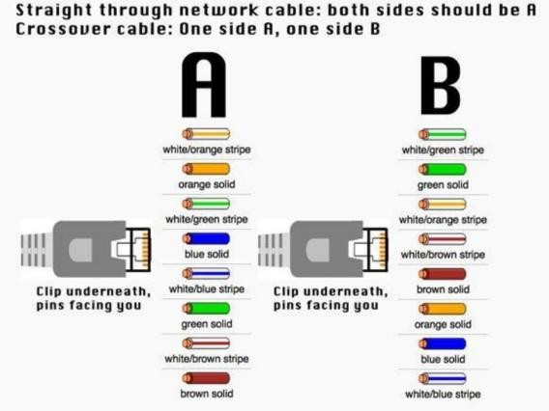

OBSERVATION
Cable | Wiring Arrangement | Usage
Straight-through cable | Same standard at both ends | PC to Switch/Router
Cable | Wiring Arrangement | Usage
Cross-over cable | Different standards at each end PC to PC

RESULT
Thus, the different types of network cables were studied, and straight-through and crossover Ethernet cables were successfully prepared using RJ45 connectors and a crimping tool. The cables were tested and found to be working properly.

